PSI ALUMNI HISTORIAN’S REPORT

Spring 2015

By T. Semmes Favrot

To be published on the Psi Chapter’s website

**The True Story Behind “Brothers in DKE”**

**PART III**

**Continued from the *Sighs of Psi* ofWinter 2015 and Spring 2014**[1]

**Back to Patten, Maine**

At the conclusion of Part II of our article on the true story behind “Brothers in DKE” in the Winter 2015 *Sighs of Psi*, we had just arrived in Edwin Rogers’ hometown of Patten, Maine, on Friday evening, August 8, 2014, where, within moments of our arrival, we had the unparalleled honor, privilege and joy of seeing firsthand the original DKE pin of Edwin S. Rogers, the Union soldier whose story is told in “Brothers in DKE.” Since the publication of that article, I have naturally been asked countless times about the identity of the present owner of the pin, and its current location. So, I guess I should go ahead and dispose of that question right here at the outset, so here’s my response: The owner of Edwin Rogers’ DKE pin wishes to remain anonymous for the time being. Having said that, the entire DKE Nation can rest assured that the pin is in excellent hands. Its value and significance, not just to the DKE community and the Rogers family, but also as a priceless relic of Civil War history, are fully appreciated, and a proper location for a permanent home for the pin is under active consideration. Further, a great deal of valuable information related to the Edwin Rogers story, much of which has been included in our prior articles as well as in this present article, has come to us, directly and indirectly, from various members of the Rogers family. This information thus represents the accumulated knowledge of this remarkable family, going back to well before Edwin’s tragic death at Cold Harbor in 1864. All Dekes therefore owe all of these numerous individuals an eternal debt of gratitude.

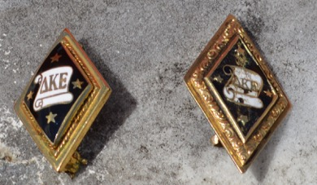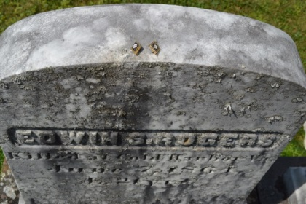

*The author’s DKE pin, left, from 1979, and Edwin Rogers’ “battered” DKE pin, right, from ca. 1861, atop Edwin’s memorial, Patten Cemetery. Notice the greater detail on the older pin.*

Flush with euphoria over our encounter with Edwin Rogers’ DKE pin, our visit to Maine continued that Friday night last August at the waterfront resort of Shin Pond Village, near Edwin’s hometown of Patten. We attended the Pioneer Barbeque with our newfound friends, followed by a silent auction and fireworks, all part of the Patten Pioneer Days festival then underway. However, we were too tired to also attend the dance at Shin Pond Pub. Worn out from a long day of travel, the excitement of seeing Edwin’s pin, and the Pioneer Barbeque, and facing a huge day the next day, we called it a night.

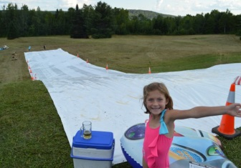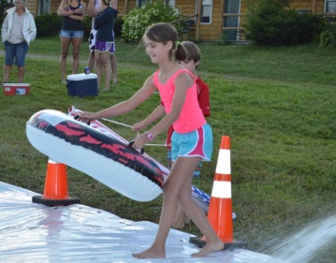

*Waterslide, Shin Pond Village.*

The next day, Saturday, August 9, began with attendance at the annual Main Street Parade in downtown Patten. I figured our research into Edwin’s hometown could only be enhanced by fully immersing ourselves into the local culture, and how better to fully appreciate a small town than to attend it’s annual Main Street Parade? Besides, my five year-old daughter and traveling research assistant, Lauren, was in need of some light entertainment before a hard day of research assistance (see photos). Unfortunately, our attendance at the parade caused us to miss the Cow Patty Bingo at Richardson’s Hardware.

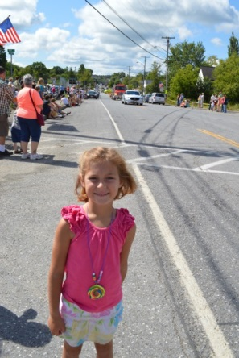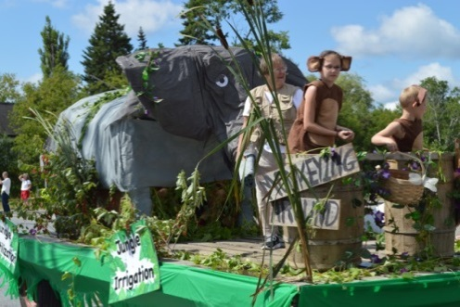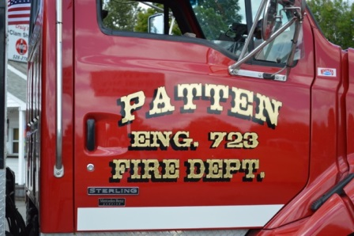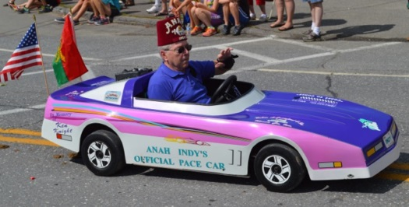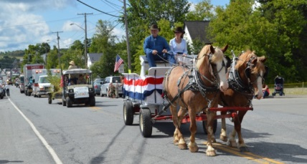

*Maine Street Parade, Patten*

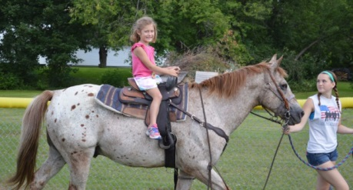

*Traveling Research Assistant Lauren gets in some R&R before going to work.*

**Edwin Rogers’ grave in Patten Cemetery**

After the parade, we headed to Patten Cemetery, on Main Street just outside of downtown. There we of course found Edwin Rogers’ “grave” (see photos). Recall from Parts I and II of this article that there is another grave purporting to be Edwin’s in Cold Harbor National Cemetery in Virginia, near where Edwin died on June 7, 1864. We hoped to find some evidence that would help us determine in which of these two graves Edwin is actually buried.

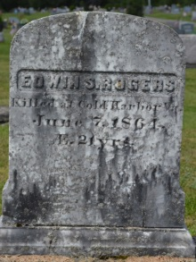

We spent a considerable amount of time at the cemetery, paying tribute to him and trying to learn about his actual burial. In addition to Edwin’s grave marker, we also found those of his parents, Dr. Luther Rogers and Hannah Bailey Rogers, as well as that of his brother, Luther Bailey Rogers, whose War Record allowed us to finally confirm beyond any doubt that the dying Edwin Rogers truly was tended to by a Confederate DKE surgeon as told in “Brothers in DKE.”[2] We also located the grave of Edwin Rogers’ nephew and namesake, Edwin Searls Rogers (1872-1957), son of Luther Bailey Rogers, who was born the year before Edwin and Luther’s father apparently received a letter from the father of Edwin’s Psi Confederate benefactor, the first of two letters relating the circumstances of Edwin’s death. This Edwin Searls Rogers was the first of four sons born to Luther B. Rogers, and Luther clearly jumped at the first opportunity to name a son after his departed brother.

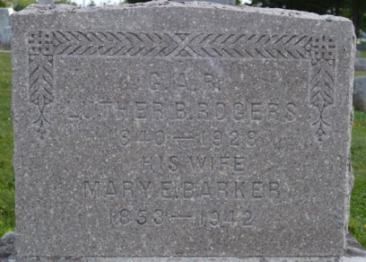 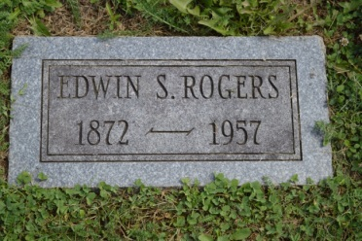

*Tombstone of Luther B. Rogers, brother of Edwin, whose War Record confirmed the ultimate truth of the “Brothers in DKE” story. Patten Cemetery; Tombstone of the second Edwin S. Rogers, nephew and namesake of our martyred Theta Deke. Patten Cemetery.*

So what did we learn at Patten Cemetery? First, we discovered that Edwin’s grave marker is carved onto the reverse side of his mother’s headstone, rather than being a freestanding headstone dedicated only to Edwin (see photos). This is unusual in itself in regard to the general layout of Patten Cemetery. The other headstones in the cemetery generally face east, while Edwin’s marker, being on the reverse side of his mother’s east-facing headstone, faces west. Since the headstones generally all face east, clearly bodies were buried on the east side of the headstones, such that the actual graves would naturally be placed in front of the headstones, with the headstones thus facing the graves. If Edwin is actually buried in Patten Cemetery, his remains would have to have been placed on the west side of his and his mother’s joint headstone, in order for his marker to face his grave. Such placement would be contrary to the general ordering of the rest of the cemetery.

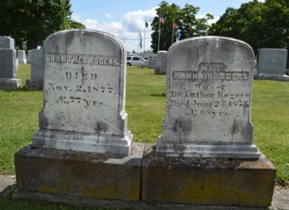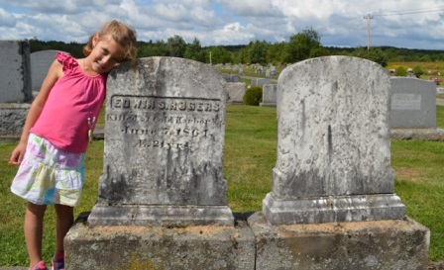

*Tombstones marking the graves of Edwin’s parents, Dr. Luther and Hannah Rogers, Patten Cemetery; Reverse side of Dr. and Mrs. Rogers’ tombstones, showing Edwin’s inscription on the rear of Mrs. Rogers’ tombstone. Dr. Rogers’ tombstone is on the right.*

Further, a close look at Edwin’s and his mother’s joint headstone seems to suggest that Edwin’s marker is only intended to be a memorial to him, rather than marking his actual gravesite. On the side of the headstone marking Mrs. Rogers’ grave, the top and side edges of the stone are carved with decorative trim (see photos). The same trim appears on the headstone for Edwin’s father, Luther, which is virtually identical in size, shape and design to that of Mrs. Rogers. This trim is noticeably absent on the side of the headstone containing Edwin’s inscription, and it thus appears plain and blank, in contrast to the detail on his mother’s side, as would be expected on a headstone that would normally be inscribed only on one side, for one person. This further suggests that the headstones for Dr. and Mrs. Rogers were standard blank headstones provided by the undertaker/stone carver who carved them, and that Edwin’s inscription was added to the reverse of his mother’s stone at the time of her death. Note that Edwin’s mother died June 23, 1875, approximately two years after Edwin’s father was said by Luther B. Rogers to have received two letters from the family of the Unknown Psi who took care of Edwin during his final hours. Recall that, in his War Record, Luther B. Rogers wrote, “It was nine years [after Edwin’s death] before we knew anything more about him, then, Dr. Rogers, his father received a letter from a man whose son had been a surgeon in the Confederate army. He said his son would write and send a pin which Edwin had given him. The son wrote the particulars of his death.”

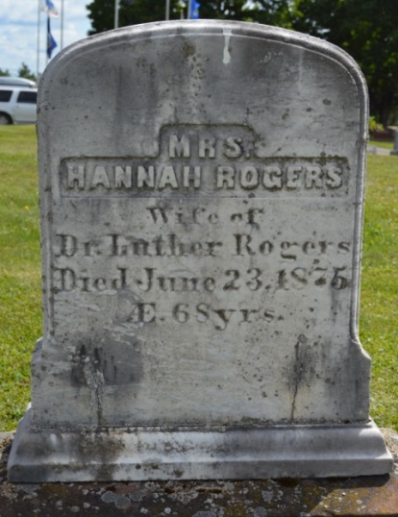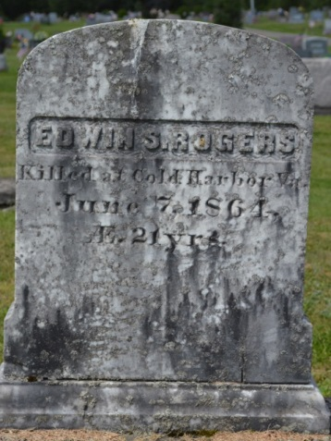

*Notice the trim carved around the top and side edges of Mrs. Rogers’ tombstone, and the lack of any similar trim on the side of the stone containing Edwin’s inscription. The lettering on both sides of the stone looks identical, suggesting both sides were carved at the same time.*

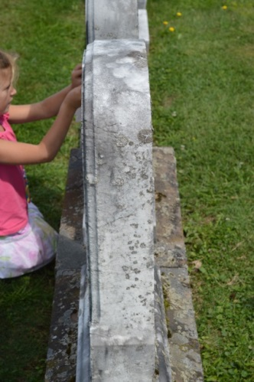

*Another view showing the presence of trim carved into the edges Mrs. Rogers’ side of the stone, but not Edwin’s.*

Since the Rogers family had no specific knowledge of the date or other exact circumstances of Edwin’s death until the arrival of those two letters around 1873, it makes sense that the family would have refrained from erecting a memorial to Edwin unless and until they knew those particulars. With the death of Mrs. Rogers two years later, it seems entirely logical, indeed, likely, that Dr. Luther Rogers took the opportunity to memorialize his deceased soldier son, Edwin, by having the stone carver who was preparing his wife’s headstone add an inscription on the back of her headstone in honor of him. A comparison of the lettering carved onto both sides of that headstone reveals them to be very similar, further suggesting that they were carved at the same time.

In light of the foregoing information developed at Patten Cemetery, along with prior evidence developed as to the location of Edwin’s actual burial, it is now the considered opinion of this author that Edwin Searls Rogers, Theta Bowdoin DKE, Class of 1865, is actually buried at Cold Harbor National Cemetery in Virginia, and that the marker in Patten Cemetery is only a memorial to him placed there by his family, in all likelihood at the time of his mother’s death in 1875, and in conjunction with her burial.

Recall from our prior articles that we had previously established the following facts:

* the Federal government has a record of Edwin's remains being disinterred in 1866 from his original burial site at the Cold battlefield, and of his being reinterred at Cold Harbor National Cemetery, but no record of his being disinterred from Cold Harbor National Cemetery, although the National Park Service advises that it is possible that such disinterment occurred but is not recorded;
* the Patton, Maine, Town Office has no record of Edwin being buried at Patten Cemetery, though it does have records of the burial of other Rogers family members who are buried there; and
* Edwin’s brother, Luther B. Rogers, wrote in his War Record of visiting Edwin’s gave at Cold Harbor National Cemetery in 1925.[3] This seems to clearly indicate that Edwin’s remains were still at Cold Harbor at that time, and that any disinterment of Edwin’s body for removal to Maine had to have occurred after 1925.

The possibility of Edwin’s remains having been disinterred and returned to Maine after 1925 seems remote. The inscription on his memorial stone clearly dates from the period of his mother’s death 50 years earlier, and while it’s possible he could have been interred at the Patten Cemetery under his pre-existing marker, surely either the Federal government would have a record of his disinterment or the Patten Town Office would have a record of his interment there. The possibility of the omission of *both* of these records seems extraordinarily unlikely.

So, it seems that we have done just about everything within reason to establish that Edwin’s actual gave is at Cold Harbor, and not in Maine. About the only other thing we could do to eliminate any further uncertainty would be to conduct a ground-penetrating radar scan of both gravesites, which should indicate the presence of a coffin and/or human remains at one of the sites. Should the Psi house corporation desire to fund such a scan, I would be happy to oversee it.

Lest anyone think that any such scan should be the responsibility of the Theta Bowdoin DKE chapter, since Edwin is one of their own, please note that the Theta Bowdoin DKE chapter has been inactive since the late 1990’s when, in its infinite wisdom, the “enlightened” forces of political correctness at Bowdoin College caused a ban on all fraternities from its campus. Despite being the second-oldest DKE chapter, founded in November 1844, only five months after Phi Yale and three years before Psi, and despite a roster of stellar alumni which includes **Admiral** **Robert Peary 1877**, who flew the DKE flag at the North Pole when he discovered it on April 7, 1909 (see photos), the Theta chapter’s 150-plus year existence was deemed unworthy of further continuance, along with that of all other fraternities on campus. We have no doubt but that student life and the college experience at Bowdoin have improved immeasurably as a result. To the Psi active chapter, please take note: if you think the house corporation and/or the university administration are hard on you, things could be far worse.

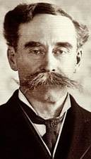 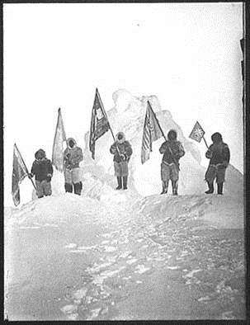

*Admiral Robert Peary, Theta Bowdoin 1877, discoverer of the North Pole. Photo courtesy of godke.org (*[*http://www.godeke.org*](http://www.godeke.org)*); The DKE flag, second from left, flies from the North Pole upon its discovery by Brother Peary on April 7, 1909. Photo courtesy of Grant Burnyeat.*

**The Lumbermen’s Museum**

After our visit to Patten Cemetery, we headed to the Bean Hole Bean Day Celebration at the Lumbermen’s Museum, just off of Main Street. The Lumbermen’s’ Museum was co-founded in 1963 by Lore A. Rogers (1875-1975), second son of Edwin’s brother, Luther, and the younger brother of the second Edwin Searls Rogers. Lore Rogers was a notable and celebrated dairy scientist, and the museum he co-founded documents Maine’s rich logging history by preserving the logging heritage and accomplishments of early pioneer inhabitants of Maine.[4] Lore’s father, Luther B. Rogers, had become a partner in a prominent lumbering operation, Ayer and Rogers, after the Civil War. The Rogers family has maintained a close connection to the Lumbermen’s’ Museum ever since, and Frank Rogers, grandson of Lore Rogers and thus a great-great-nephew of our martyred DKE, Edwin, serves as its current President.

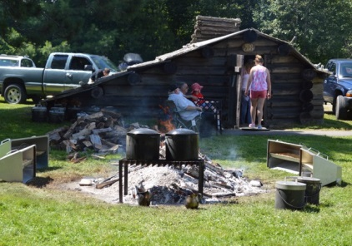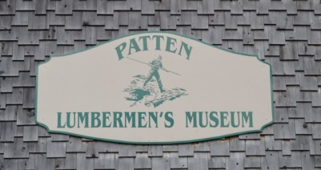

*“Bean hole” beans cooking at the Logger’s Dinner, Lumbermen’s Museum, Patten.*

The Logger’s Dinner at the Bean Hole Bean Day Celebration at the museum was one of the culminating events of the Pioneer Days festival, and I had been advised that several Rogers family members would be in attendance. The “Bean Hole” refers to the traditional Maine lumber camp method of slow-cooking beans over a fire. The traditional “bean hole” is a stone-lined pit in which a fire is built until a good bed of coals forms.  A cast iron bean pot is lowered into the pit, covered with soil and allowed to cook, usually overnight.[5] It was thus only fitting that the Lumbermen’s Museum would center its signature event of the festival around this traditional dish. I can personally attest to the gastronomic success of bean hole beans, so much so that I am surprised that this method of cooking beans has not become pervasive in the South.

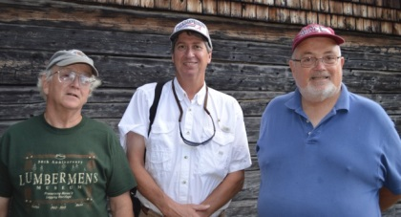

*At the Lumbermen’s Museum.  Left to right: Frank Rogers, President of the museum, the author, and Edwin A. Rogers.*

In addition to experiencing enjoyable new flavor profiles via bean hole beans and related Maine fare, we also did have the distinct honor and privilege of meeting several Rogers family members. Frank Rogers, the aforementioned President of the museum, was there and proved a most gracious host. In addition, we met Edwin A. Rogers, brother of Frank and thus also a great great nephew of the original Edwin. It was Edwin A. Rogers who informed me that Patten was the hometown of former Crimson Tide head football coach Harold “Red” Drew.[6] Also present and extremely hospitable was Rogers family member Caroline Woodward, whose brother, Tom Shirley, has been of invaluable and much-appreciated assistance to me in this research, and who helped arrange our visit to Patten and Shin Pond, and who I was thus looking forward to meeting in person. Tom was notably absent, a personal matter having prevented his attendance at the week’s festivities at the last minute. Tom and Caroline are both great-great grandchildren of Luther B. Rogers.

All of these Rogers family members, along with other family members who were not present at the time, are quite familiar with Edwin’s story and its memorialization through our iconic DKE poem. They were also familiar with and very supportive of our efforts to research the story further. It is interesting to note the extent to which Edwin’s story and the poem have remained a part of Rogers family lore, just as they have within DKE. Tom Shirley advises, “This story is one that our family has retold through the generations.” Despite the common interest in this story, there doesn’t seem to have been any direct connection between the family and DKE for quite a long time. We are thus pleased to have had a part in reconnecting the two. Unfortunately, none of the Rogers family members with whom we have been in contact have ever seen either of the two letters written to Dr. Luther Rogers about Edwin’s death around 1873, nor does anyone have a clue as to what happened to these letter or where they might be now.

It was through Tom Shirley that we had also learned that we were not the first to write about the Edwin Rogers story since John Clair Minot published “Brothers in DKE” in 1897. Around 1996, when Tom’s son was in grade school, class plays were written using stories from the families of the children in his class. A play was written and performed based on the Edwin/DKE story at that time.[7]

Another site we had hoped to see on our trip to Patten was the Rogers family home where Edwin Rogers was raised. We learned from our friends at the Logger’s Dinner that, unfortunately, the original home is gone, though the property on which it sat is still owned by a member of the family. The property is on the outskirts of Patten, not far from the Lumbermen’s Museum.

G:\Clients\Delta Kappa Epsilon\DKE AL\Website\Historian\Rogers family farm.jpgG:\Clients\Delta Kappa Epsilon\DKE AL\Website\Historian\winter view.jpg

*Rogers family farm, Patten, Maine, where Edwin Rogers grew up.  The old farmhouse pictured is no longer standing. Photo courtesy of the estate of Ruth Rogers MacLean; Winter view- Rogers family farm, Patten, Maine.  Photo courtesy of the estate of Ruth Rogers MacLean.*

**Patten Historical Society**

After enjoying the Logger’s Dinner with our newfound friends and then touring the museum, we resumed our research. We were told there was something at the Patten Historical Society building that we would want to see. The Patten Historical Society is housed in a nice old 19th century home on Main Street in downtown Patten. On the side of the building is a plaque captioned, “Roll of Honor of the Students of Patten Academy Who Served in the War of 1861-5.” There, as expected, we found the names of both Edwin and his brother, Luther (see photos). We also learned that this building, and more particularly, a prior owner of it, had another curious connection to our story.

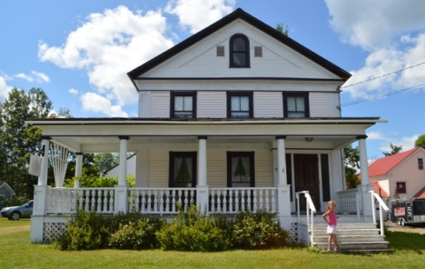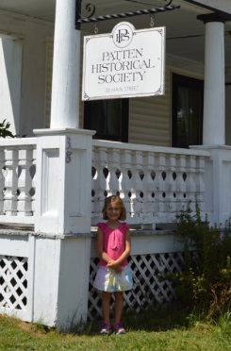

*Patten Historical Society, Main Street, Patten.*

After visiting the Historical Society building and some further touring around town and in the surrounding countryside, we returned to our accommodations at Shin Pond Village, where we relaxed for the rest of the day and night. A huge waterslide kept the four Favrot children occupied for the rest of the day, much to my relief.

The following day, Sunday, marked our departure from Edwin’s hometown. Before leaving, we stopped again at Patten Cemetery to take more photos, due to better lighting conditions than we had had the day before. My Traveling Research Assistants unfurled the DKE flag we had brought for the occasion, in a final tribute to Brother Rogers (see photos). Then we headed south. But we were not yet done with Maine.

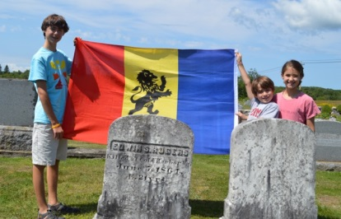 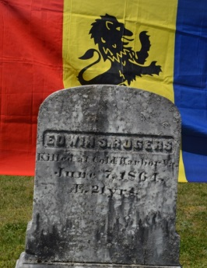

*The DKE flag at Brother Rogers’ memorial, Patten Cemetery; The Rampant Lion and Brother Rogers.*

**“ ‘*I'm from Theta*,’ said the Yankee….”- Bowdoin College Campus**

I could not leave Maine without a visit to Edwin’s alma mater and the home of the now-inactive Theta DKE chapter. On Monday, August 11, after leaving my family comfortably ensconced at accommodations in the town on Freeport, I headed for the Bowdoin College campus. In Part I of this article, we had concluded that Minot’s line in “Brothers in DKE” which reads, “*The Northern soldier's name is found on Bowdoin's honor-roll*” referred to a booklet captioned "Roll of Honor; List of Members of Bowdoin College who have Served in the U.S. Army or Navy During the War of the Rebellion."[8] I now knew there was more to this.

After a stroll through the campus, I located what I was looking for. Inside Memorial Hall, built between 1867 and 1882 as a memorial to Bowdoin's Civil War veterans, I found the actual Bowdoin “honor-roll,” a bronze plaque listing the names of all Bowdoin students and alumni who fought for the Union in the Civil War.[9] As expected, we found Edwin Rogers’ name, along with other members of the Bowdoin Class of 1865 (see photos).[10] Just above Edwin’s name, we also found that of **Brother Leander Otis Merriam**, Edwin’s fellow Theta DKE and fellow member of the 31st Maine Infantry, whose unpublished Personal Recollections- The War for the Union, gave us the first clear evidence that Edwin had been wounded and captured at the Battle of Cold Harbor, rather than having been left wounded on the battlefield as suggested in Minot’s poem.[11]

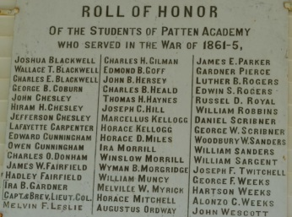 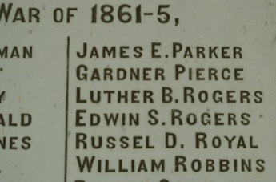

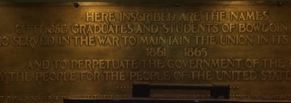 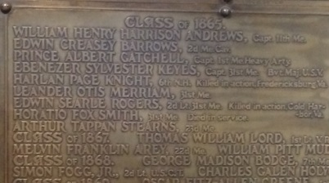

*“Roll of Honor,” Memorial Hall, Bowdoin College.  Please pardon the poor quality photo; Edwin S. Rogers’ and Leander O. Merriam’s names on the “Roll of Honor,” Memorial Hall, Bowdoin College.*

Interestingly, adjacent to the plaque honoring Bowdoin’s Union soldiers, there is another plaque inscribed, “In Memory Of The Bowdoin Men Who Served With The Confederate Forces 1861-1865” (see photo). The names of 18 Bowdoin Confederate soldiers are inscribed thereon, along with an inscription for Confederate President Jefferson Davis, under the caption “Honorary,” dated 1858. Jefferson Davis never attended Bowdoin as a student, but it turns out that on a tour “Down East” in 1858, then-Mississippi U. S. senator and former U. S. Secretary of War Jefferson Davis was awarded an honorary degree by Bowdoin College, a courtesy then often paid to visiting dignitaries. Despite political pressure after the Civil War, Bowdoin never rescinded the honor. There is a letter in the Bowdoin College archives from Jefferson Davis dated July 3, 1889, five months before Davis’ death, expressing his gratitude that Bowdoin did not rescind Davis’ honorary degree.[12]

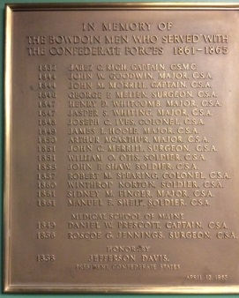

*Confederate “Roll of Honor,” Memorial Hall, Bowdoin College.*

Unexpectedly stumbling upon this plaque was quite a pleasant surprise for a Southern boy who found himself chasing the ghost of a dead Yankee soldier deep in the northernmost state in the Lower 48. We can only hope that the same “enlightened” forces that shut down the Theta DKE chapter do not end up subjecting this plaque to a similar fate.

**Maine State Archives**

I had one more stop to make in regard to Brother Rogers’ ghost while in Maine: the office of the Maine State Archives, in the state capital of Augusta. After my visit to the Bowdoin campus, I headed there. I had one specific item I was looking for, and one more general inquiry. The specific object of my visit was to locate the Maine Adjutant General’s record alluded to in Brother Leander O. Merriam’s eyewitness account of Edwin’s wounding and capture, referenced in Part I of this article.[13] After relating his version of Edwin’s fate, Merriam states, “The record in the [Adjutant] General 's office says that the rebels started him toward Richmond as a prisoner, but it was so evident that he could not live, they left him in a farmhouse on the way, where he *died.*”[14] I had thus far been unable to locate the subject “record”, and was hoping to find additional details on Edwin in it. The Maine Adjutant General, who was the top military official of the state, published Annual Reports during the Civil War years, which were apparently the “records” referred to by Merriam. Until now, I had only located the Annual Report for 1866, which contains several passing mentions of Rogers’ death on June 7th, 1864. I was advised that a full set of these reports was available at the state Archives.

More generally, it seemed possible that the state Archives might have some evidence of the identity of the Unknown Psi, who returned Edwin’s DKE pin to Maine years after his death. In speaking with the Archives staff about the sought-after Adjutant General’s Reports, I was fortunate to be assisted by Mr. Anthony Douin of that office. After telling him the basic “Brothers in DKE” story, Mr. Douin advised me of some other records in the Archives which might be of help. I had told him that the Southern DKE and his father had located Dr. Rogers nine years after the war, and the only indication we had of how the Southern family had located Dr. Rogers came from Luther B. Rogers statement in his War Record that the Southern DKE had “said he published the account in such newspapers as he thought would be most likely to reach Edwin’s friends,”[15] but that we had thus far been unable to locate any such published “account.” Mr. Douin suggested that there might be some correspondence from the Southern family in the Maine Adjutant General’s files from the period, inquiring as to the whereabouts of Edwin’s family. As the top military officer of the State of Maine, said Mr. Douin, it would not have been unusual after the war for someone to have contacted the Adjutant General (“AG”) seeking information on a particular Maine soldier, and that perhaps the Southern family had contacted the Maine AG seeking assistance in tracking down Edwin’s family. I was invited to look through this correspondence to see what I could find.

Upon arrival at the Maine Archives and meeting Mr. Douin in person, I then quickly located the AG’s report that I had been seeking. The AG published one report for 1864-1865, which thus covered the period of Edwin’s death in June 1864. I found a half-page biographical entry on Brother Rogers, which provided a few new details on him. We include it here in its entirety, as this short bio was obviously the source of some of the subsequent writings on Brother Rogers that we had seen previously, and should thus probably be considered authoritative. It probably also serves as a fitting epitaph to our research on him:

*“Edwin Searle Rogers was born in Patten, Jan. 31st, 1843, and was a student at Bowdoin College in the class of 1865. While in his junior year, regarding it to be his duty to enter the U. S. Service, he left college in Feb., and returned to Patten, where he enlisted about 30 men, and was thereupon commissioned 2d Lieut., Co. E, 31st* Regt. *Maine* Vols., *and was mustered into the U. S. service, in March, 1864, at Augusta* [Maine]. *In the absence of superior officers, he took and held command of the company until within a few days of his capture and death.*

*“Lieut. Rogers was in the battle of the Wilderness and shared in the dangers of the eight days’ fighting and fatiguing marches previous to the battle of Spottsylvania, in which he also participated. He was again with his regiment in the subsequent actions and marches until the battle of Cold Harbor, where, on the 7th of June, 1864, while in command of a picket line, he was struck by a rifle-ball, which passed through his lungs. He was then taken prisoner and left by the rebels in a tent on their way to Richmond, where it is conjectured, he died on the same day.*

*“The deceased was a young man of much promise, genial in society and in camp, and brave on the field, thus winning the affection of his comrades and the approbation of his superior officers.”*[16]

This entry for Brother Rogers was clearly the source of the information on him that we had found in the 1882 History of Penobscot County, Maine which we cited in Part I of this article.[17] It was also both explicitly and implicitly cited in L. O. Merriam’s Recollections.[18]

Next I turned to the AG’s correspondence from after the Civil War. I expected to be provided with photocopies or microfilm copies of this correspondence, but instead I found myself reading the actual original correspondence; handwritten letters written mostly by Civil War veterans themselves. Typical letters included requests for duplicate copies of discharges from military service after the war, requests for assistance obtaining pensions or bounties, and assistance in locating other veterans. Some of the most poignant letters were from former Confederate soldiers, seeking the whereabouts of a specific erstwhile Union enemy against whom they had fought in particular battles, and who now sought to return captured property, or tell the family of a slain soldier the details of his demise. In short, there were several such inquiries made under circumstances eerily reminiscent of the type of inquiry we hoped to find as to Edwin Rogers.

I spent the better part of a day sifting through the Maine AG’s correspondence, but in the end was unable to find anything from the Unknown Psi, his father or anyone else as to Brother Rogers. Our quarry still eluded us.

Thus ended our trek to Maine in pursuit of the ghost of Edwin Rogers. We had learned a great deal thus far in our pursuit of this story, on this trip and through our previous efforts. We had learned much about the true details of Brother Rogers’ demise, and determined that, while John Clair Minot got many of the fine points of Edwin’s story wrong in his poem, the underlying tale of a dying Northern DKE soldier being encountered on a battlefield in Virginia in 1864 by a fellow DKE from the South is absolutely, positively true. We had walked the battlefield where this clash took place, and at least gotten close to where all of these incidents went down. We had determined in which of two purported graves Brother Rogers is actually buried. We had met and rubbed elbows with his kinfolk. And we had had the unparalleled thrill of seeing, touching and photographing Edwin’s original DKE pin.

But many questions remained unanswered. Where are the two letters from the South which told Dr. Rogers of his son’s death? What do those letters say? How did the Southern family find Dr. Rogers? Who or what was the ultimate source of the story as told to John Clair Minot, thus inspiring him to write his immortal poem? Luther B. Rogers tells us that Minot heard the story from another Theta DKE named Herbert N. Gardner, but who exactly was Herbert N. Gardner, and what was his connection to Brother Rogers, and thus what was his source for the story?

Oh, and of course: ***just who in the heck is the Unknown Psi, anyway????***

To be continued in the next *Sighs of Psi*….

In the Bonds,

T. Semmes Favrot ‘82

New Orleans, La.

Alumni Historian

[sfavrot@cox.net](mailto:sfavrot@cox.net)

1. Parts I and II of this article can be found online at: <http://www.epageflip.net/i/302013-spring-2014-newsletter> and <http://www.epageflip.net/i/454342-winter-2015-newsletter>
2. See Part II of this article, *Sighs of Psi*, Winter 2015.
3. From Luther Rogers’ War Record: “I visited his grave in 1925 and found it in a National Cemetery on the battle field of Cold Harbor about five miles from Richmond. It is well kept. The stone has inscribed on it his name, rank and regiment, also the date of his death.”
4. See “Lore Alford Rogers”, <http://en.wikipedia.org/wiki/Lore_Alford_Rogers>, and the Lumbermen’s Museum website, <http://www.lumbermensmuseum.org/about-us-2/>
5. Information from the Maine Organic Farmers and Gardeners Association, http://www.mofga.org/Publications/MaineOrganicFarmerGardener/Winter20062007/CommonGroundsBeanHoleBeans/tabid/659/Default.aspx
6. See Trivia Question, *Sighs of Psi* Winter 2015, page 11.
7. A copy of the script for this play is in the possession of the author, courtesy of Tom Shirley.
8. See Part I of this article, *Sighs of Psi*, Spring 2014, Footnote 9.
9. http://www.bowdoin.edu/about/campus/tour/memorial-hall/index.shtml
10. Bowdoin’s Memorial Hall is now home to a 600-seat theatre, and I showed up just as people were arriving for a theatrical event. A desk manned by students admitting people to the theatre was set up right in front of the Roll of Honor, and these students seemed somewhat annoyed at my efforts to photograph the Roll of Honor during the admission process. Thus, my photography was somewhat rushed, resulting the accompanying poor-quality photos.
11. L. O. Merriam Recollections, Fredericksburg and Spotsylvania National Military Park Library; see also Part I of this article, *ibid*, page 8.
12. Bowdoin College website: http://www.bowdoin.edu/about/history/index.shtml
13. See Part I of this article, *ibid*, page 8 and footnote 13.
14. See Part I of this article, *ibid*, page 8 and L. O. Merriam Recollections, page 45.
15. Quoted in Part II of this article, *Sighs of Psi*, Winter 2015, page 6.
16. Maine Adjutant General’s Report for 1864/1865, page 442.
17. *Sighs of Psi*, Spring 2014, page 7 and footnote 9.
18. *Ibid*, page 8.